Startime For Juici Patties Clarendon Park Saturday July 2. !!

Jamaica’s premier vintage show The Original Startime, the show that was launched 27 years ago with the mission to “keep Jamaica’s musical heritage alive” is back with bang after a three-year break. Startime which has also established itself as one of Jamaica’s most highly- rated entertainment events, left the scene in 2006 after 18 consecutive years and over 140 concerts, and then made a triumphant return with two successful concerts in 2013.
Entertainment writers have often stated that Startime’s absence “had left a major void in the capital city’s entertainment offerings” and the public pressure for the show’s return has been so strong that the promoters had no alternative but to respond to the public’s insistence that Startime goes back into production.
Then earlier this year, the celebrated series returned with a spectacular staging at Mas Camp, Kingston on January 9, headlined by Reggae Queen Marcia Griffiths that had a jampacked Mas Camp in musical ecstacy; and now the Startime faithful want more and more of the artists and the music of the pioneering ska, rock steady and early reggae eras of the 60s and 70s.

/ 2 /

This beautiful musical tapestry will be on show once again in all its glory, come Saturday July 2, 2016 at the Juici Patties Clarendon Park venue in Toll Gate, Clarendon; when Juici Patties will present the highly-rated, world-famous Original Startime featuring another stellar line up of ska, rock steady and reggae superstars, in association with Kool 97FM, Jamaica Observer, Sparkles Productions, On Stage TV,
Irie FM, Singer, Seals & Engravables, Devon Bourne’s Rubis, C.P.T.C., A & E Ambulance Services, Securipro who will provide security and Interlinc Communications host of the startime.com.jm website. Knutsford Express will be providing bus service from all their locations across Jamaica to patrons who do not wish to drive.
These three leading Jamaican musical genres will be spotlighted as the cast represents some of the finest exponents to have graced the Jamaican performing stage over the past 65 years.
Stamping their class on another historic Startime concert will be the first lady of Reggae, Queen Marcia Griffiths and Leroy “Heptones” Sibbles both celebrating an incredible 52 years of recording and performing classic Jamaican music; 80s DJ superstar Frankie Paul will be flying in from Gambia where he now resides; Horace Andy; Errol Dunkley; the Mighty Diamonds celebrating 47 years together as a group; 70s hit machine Johnny Clarke and 70s ace DJ Dillinger.
/ 3 /
As if all of the above were’nt enough … the late-breaking news is that this remarkable line up above will be joined by the “Clarendon Connection” of reggae superstar Freddie McGregor, King of Ska Derrick Morgan and the 60s hit-making duo the Clarendonians comprising original members Peter Austin and Ernest Wilson – all Clarendon natives who are returning to their roots to thrill the thousands of Startime fans expected to fill the spacious Clarendon Park venue. All these artists will be backed by Jamaica’s no.1 band Lloyd Parks and We The People also known as the Startime Orchestra, and Tommy Cowan will provide m.c. duties.
Clarendon will never be the same after the musical onslaught expected from these foundation giants on Saturday July 2.
Keep reading the Jamaica Observer and visit the Startime facebook page: The Original Startime Vintage Series for all the breaking Startime news.
It is almost too good to be true, and too great to be missed !!!
Photos below :
Marcia Griffiths Freddie McGregor Leroy Sibbles Horace Andy Derrick Morgan Frankie Paul
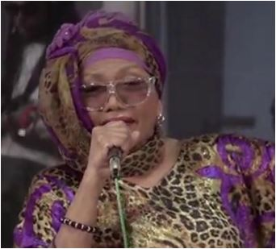 MMM

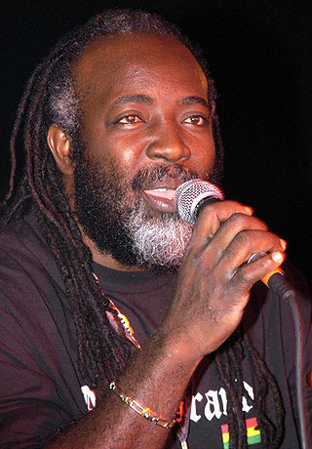 FFre
